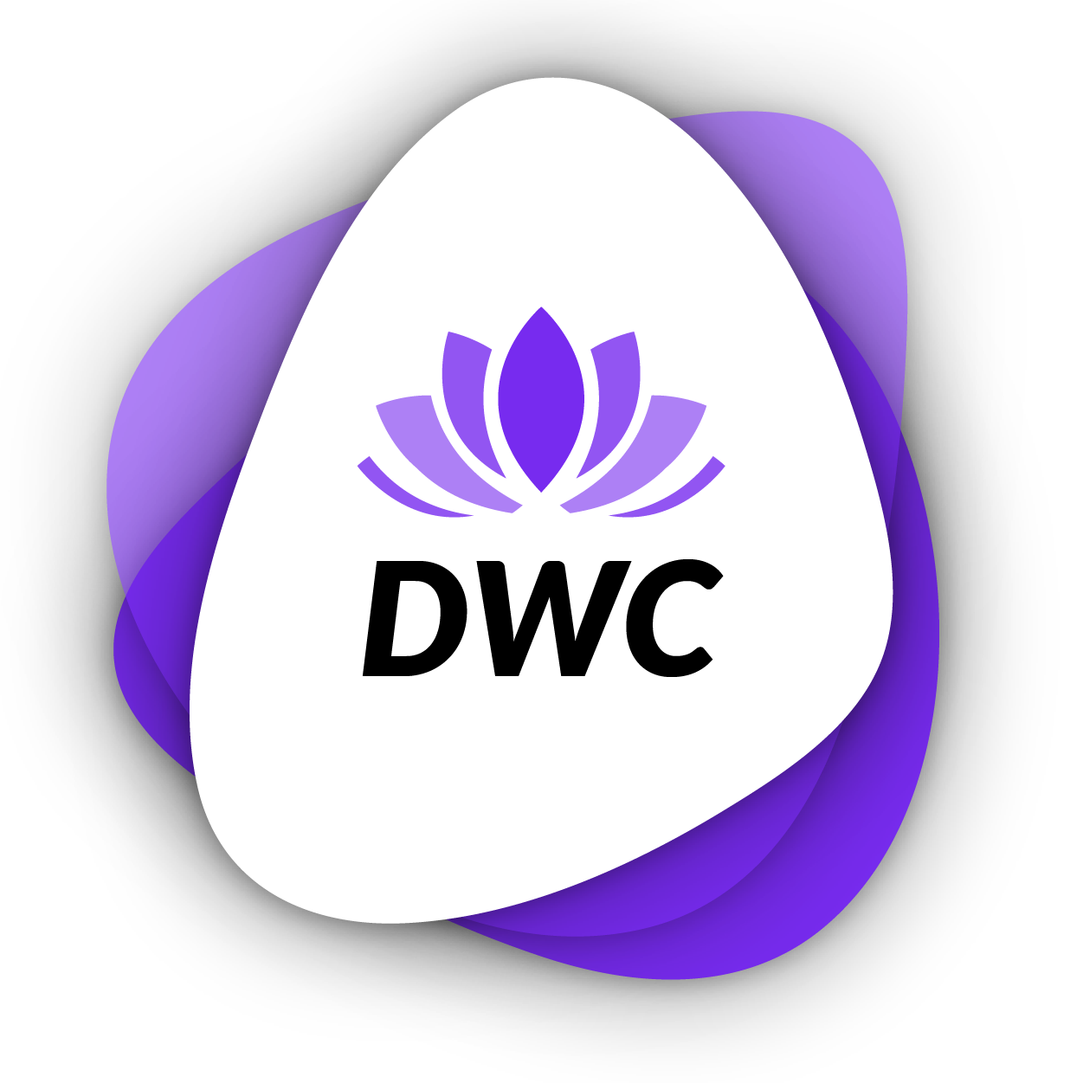
DWC Pedagogical Programme Proposed
Adaptable Variable-Access Approach
-
Teaching & Learning Methodologies for Cosmetology & Wellness courses in VET through the DWC Digital Staff Handbook

Table of Contents
Background 2
Part 1: Preparation for remote-access learning 3
Part 2: Development of key digital competences in tutors/educators to allow effective remote teaching/learning 4
Part 3: Trainee/Student Remote Blended Learning Potential Pedagogical Approach 6
Part 4: Exchanges within learning groups at local, regional, national & European levels 6
EU Disclaimer & Creative Commons Licence 7

Background

The EFT report on ‘Digital Transformation challenges & opportunities for Vocational Education & Training’’ mentioned that ‘THE DIGITAL CHANGE CANNOT BE DELEGATED TO THE TEACHING STAFF, BUT MUST BE SYSTEMATICALLY CONTROLLED, ACCOMPANIED, EVALUATED & DEVELOPED BY THE SCHOOL MANAGEMENT AS PART OF A CHANGE PROCESS’.

‘Especially for IVET, digital learning widens access to relevant & quality skills development solutions, for example through MOOC’.

This research highlights the essential aim of our project & its first output. We see that it is a necessary means to change the way VET courses are taught targeting the upskilling of VET Cosmetology & Wellness teachers’ digital competences.

With regard to developing digital skills in tutors & educators, there is a wealth of resources currently available– so many in fact that it is a real challenge to identify the most useful for educators to facilitate & monitor the learning of their learners & create/use digital learning resources. Before designing & creating the project resources, one of the requirements for the project will be the identification of the most useful & appropriate digital platforms.

Part 1: Preparation for remote-access learning

What is remote access learning or blended learning?

Blended learning is made up of two axes:

- an online axis, possibly at home, controlled as appropriate in terms of the time allotted, the place where it takes place, the pace of learning, the chronological order of the sequences
- an axis on site, face-to-face, for example at school

The student's learning path must be marked and offer an integrated experience, for example by means of a learning platform.

It gives the possibility of individualizing the sequences of lessons and the formative and summative evaluations and allows the student to progress at the rate of mastery of skills and not according to a time defined by the teacher. It is a way to make the student more autonomous and to adapt the teaching offer to his potential, while respecting the prescriptions of the course programs.
https://www.blendedlearning.org/basics gives 7 models of blended learning that can be combined as needed.

However, NO BLENDED LEARNING CAN TAKE PLACE WITHOUT EQUIPMENT

Creating the Environment:
- A workspace suitable for learning or working
- A desk/table and a chair suitable for sitting for a long time
- A computer or tablet that allows the trainee and/or student to learn and work
- A good internet connection
- Support tools such as good quality headphones, mouse, speakers etc...

Some suggestions:
- Staying in front of a digital device for a long time is not recommended:
- Take small breaks every now and then
- Make sure an adequate distance from the monitor
- Get comfortable & try to maintain adequate posture
- If necessary, use specific glasses for the use of digital devices

Digital equipment:
- Account for access to the videoconferencing tool like Teams, Skype or Zoom.
- Mailbox and account for access to the cloud user like Gmail, OneDrive, GoogleDrive or Dropbox
- Graphic programmes like Canva, Photoshops, Pixir etc
- Communication software programmes like Openboard, PowerPoint, Google Slides, Word, etc.
- Social media channels: Facebook, Linkedin, YouTube channels, etc...
- Video editing software – free software
- Instruction and use of common translation software – Google Translate, Wordreference or Deepl
- Planification Tools like Google Calendar or Teams Calendar
- Communication channels like Openboard, PowerPoint, Slides Office, Word, etc.

Part 2: Development of key digital competences in tutors/educators to allow effective remote teaching/learning

UNESCO has produced a COVID19 Response Toolkit, which presents a strategy for remote learning, remote learning platforms for hybrid (blended) learning. The ‘Skills for Life Network’ features a wide range of innovative & relevant resources to support digital skills development.

The ‘Enhance Digital Teaching Platform’ has resources to help educators develop their practice using technology. Of particular note here are the possibilities proposed for access anywhere, anytime & via any device.

Google & Microsoft have produced materials that can facilitate remote learning during the COV19 pandemic. This includes online tutorials on video calls, livestream, & voice-typing. Both offer free access & learning resources to present their functionalities.

We will develop teachers' awareness & capacity to make effective use of the most valuable digital tools.

This will be in the form of a Digital Handbook. It will enable Cosmetology & Wellness VET course teachers to create & adapt their own online digital learning resources to suit the precise needs of their learners in light of COVID19 or any future pandemic constraints if required to work remotely.

The precise content of the programme will be developed following the results from the analysis to be carried out in O1, but our initial research suggest that they would include the following educator digital competence areas

- How to use video editing software
- How to make effective commentaries
- How to make static & dynamic screen captures
- How to create & adapt graphics
- How to adapt & modify sample video tutorials, interactive learning activities & model answers
- How to create a YouTube channel & upload completed tutorials, learning activities & answers
- How to use communication applications to effectively monitor trainees remotely

Below are hyperlinks to Digital Competence Development Modules for the 7 topics above, each with a video tutorial, challenges & guidance, developed in the DSKILTI project in 6 languages:

Language | DSKILTI Output | Easy Download Link
English | 1.2. DSKILTI Modules 1-8 for VET Tutors with Challenges & Guidance EN | https://bit.ly/3OaPqWx
Français | 1.2. Modules 1 à 8 de DSKILTI pour les tuteurs de formation professionnelle avec défis et conseils FR | https://bit.ly/3M7xHg1
Deutsch | 1.2. DSKILTI Module 1-8 für Ausbilder in der Berufsbildung mit Herausforderungen und Anleitung DE | https://bit.ly/3IbiDNo
Italiano | 1.2. DSKILTI Moduli 1-8 per tutor di IFP con sfide e guida IT | https://bit.ly/3M33e2R
Portugues | 1.2. Módulos 1-8 do DSKILTI para tutores de EFP com desafios e orientação PT | https://bit.ly/3IdPFfX
Espagnol | 1.2. Módulos 1-8 de DSKILTI para tutores de EFP con desafíos y orientación ES | https://bit.ly/3OcMcSG

HOW TO USE THE EBOOK – short presentation video for educators: https://www.youtube.com/channel/UCTCxr5H2rE7gg2_lzG4f7LQ

Part 3: Trainee/Student Remote Blended Learning Potential Pedagogical Approach

Step 1: For each Interactive learning activity there will be a short, animated video clip presenting all key information – this would be like a lesson given by a teacher or trainer. 1 video per module with a section for each sub-module with a marker per section.

Step 2: After watching the video tutorial, the students can work through the content in the ebook. There will be a series of interactive learning activities to reinforce their learning -this would be like a series of tasks set as an assignment.

Step 3: When the learners have completed the interactive learning activity, they can compare their results with the results prepared by the DWC at the back of the ebook - this would be like getting their work back & checking how they did. Students make a list of all the points that they do not fully understand.

Step 4: For further assistance & when they do not understand a particular aspect, learners can ask their tutor questions in a group session and/or via the CoP &/or discuss in subsequent group sessions (see Step 4).

Step 5: End of Module Quiz - there will be a short quiz to check that learners have learnt the major points – this is like an end of unit assessment test.

Each interactive learning activity can be used by learners autonomously or in a group situation. Likewise, the steps can be completed in a different order if required or more appropriate.

Part 4: Exchanges within learning groups at local, regional, national & European levels

The DWC project aims to encourage exchanges between educators & learners through a practical adaptation of the COMMUNITY OF PRACTICE MODEL (CoP), developed by Wenger (1991).

The DWC partners believe passionately in the concept of COMMUNITY OF PRACTICE. However, a community of practice model should not be limited to the local area or the regional area or even within member states. The potentially most useful & impactful CoP is a community built around the entire European Area.

Partners also believe that educators & learners of different nationalities have skills competencies & experiences which if they share these with other learning groups, the amount of learning can be increased & the opportunities for meaningful & fulfilling employment dramatically increased.

INNOVATIVE ASPECTS:

- Creating stimulating opportunities for target groups from different countries to exchange knowledge in a non-formal way, using interactive pedagogical methods & create lasting relationships
- Valuing & recycling knowledge, experience & culture – repackaging & reselling for future benefits in new potential life & professional opportunities

We propose THREE potential CoP’s, designed & structured to meet specific needs:

Educators:
- Between educators within the same organisation
- Between educators from one of more different organisations from the same country
- Between educators from organisations from different countries
- Suggested platform: EPALE

Educators & Trainees:
- Between educators & learners within a learning group in one organisation
- Between learning groups in one organisation & learning groups in another organisation from the same country; Between learning groups from different countries
- Suggest platform: Signal/WhatsApp

Trainees:
- Between within a learning group in one organisation
- Between learners in one organisation & learners in another organisation from the same country
- Between learners from different organisations from countries
- Suggest platform: Signal/WhatsApp

EU Disclaimer & Creative Commons Licence

